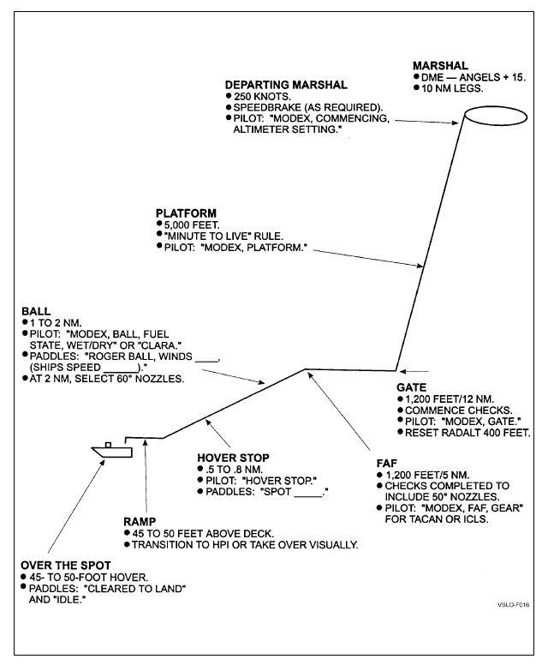

**LHA Case 3 Recovery**